Practical 6 - Installation and Configuration of Open Source Web Server and Database
1. Aim: -
To install and configure an open-source web server (Apache) and an open-source database (SQLite), and to perform basic web server operations and database connectivity testing.
2. Requirements: -
Hardware:
- A computer/laptop with minimum 4GB RAM
- Minimum 10GB free disk space
Software:
- Linux Operating System (Ubuntu, or LabEx virtual terminal environment)
- Terminal application (bash shell)
- Internet connectivity (required to download and install Apache and SQLite packages)
3. Theory
Apache HTTP Server (apache2) is a free, open-source web server that accepts HTTP requests from clients and serves static or dynamic web content in response. Once installed, it runs as a background service (daemon) that listens for incoming connections on port 80 by default, and it serves files placed inside its document root directory, /var/www/html. The service can be controlled using sudo service apache2 start, stop, or restart, and its status can be checked at any time to confirm whether the server is actively running.
SQLite is a lightweight, serverless, open-source relational database engine. Unlike client-server databases such as MySQL or PostgreSQL, SQLite does not require a separate running database service - the entire database (schema, tables, and data) is stored in a single file on disk, and it is accessed directly through the sqlite3 command-line tool or embedded within applications. It supports standard SQL statements such as CREATE TABLE, INSERT, SELECT, UPDATE, and DELETE, making it well suited for small-scale applications, prototypes, and learning environments where a full database server would be unnecessary overhead.
curl is a command-line utility used to transfer data to or from a server using protocols such as HTTP. In this practical, curl http://localhost is used to send a request to the locally running Apache server and display the HTML response directly in the terminal, providing a quick way to verify that the web server is running and serving the expected content without needing a graphical browser.
Before installing new software, the local package index should be refreshed using sudo apt-get update, which downloads the latest list of available packages from the configured repositories. Once refreshed, sudo apt-get install -y <package> installs the requested package(s) - here, apache2 and sqlite3 together - along with any missing dependencies, with the -y flag automatically confirming the installation prompt. Understanding this workflow - updating the index, installing, starting the service, and verifying connectivity - forms the foundation of setting up any open-source server software on a Debian-based Linux system.
4. Procedure: -
The following steps were executed in sequence in a Linux terminal (compatible with both LabEx and a standard Ubuntu terminal). Each step's command(s) are shown below, followed by an explanation of what the command does.
Step 1: Create Practical Folder
mkdir webdbprac
cd webdbprac
pwd
Creates a new folder named webdbprac, moves into it, and prints the current working directory to confirm the location (e.g. /home/labex/project/webdbprac or /home/student/webdbprac depending on the system).
Step 2: Update Package List
sudo apt-get update
Refreshes the local index of available packages by downloading the latest package information from all configured repositories. This does not install or upgrade any software - it only ensures that the subsequent install command uses up-to-date package data.
Step 3: Install Apache Web Server and SQLite Database
sudo apt-get install -y apache2 sqlite3
Installs the apache2 web server package and the sqlite3 database engine together in a single command, along with any missing dependencies. The -y flag automatically answers "yes" to the installation confirmation prompt, allowing both packages to be installed without manual intervention.
Step 4: Start Apache Web Server
sudo service apache2 start
curl http://localhost
Starts the Apache service so that it begins listening for HTTP requests on port 80. The curl command immediately after sends a request to the local server and prints the HTML of the default Apache placeholder page, confirming that the web server has started successfully.
Step 5: Create a Simple Web Page
echo "<h1>Welcome to Open Source Web Server Practical</h1>" | sudo tee /var/www/html/index.html
Overwrites the default index.html file inside Apache's document root (/var/www/html) with a custom HTML heading. Since this directory is owned by the root user, sudo tee is used instead of a plain redirect (>) so that the write operation has the necessary permissions.
Step 6: Test Web Server
curl http://localhost
Sends another request to the local Apache server and displays the response in the terminal, confirming that the custom "Welcome to Open Source Web Server Practical" page created in the previous step is now being served correctly.
Step 7: Create SQLite Database and Table
sqlite3 student.db "CREATE TABLE students(id INTEGER, name TEXT, course TEXT);"
Creates a new SQLite database file named student.db in the current directory (if it does not already exist) and defines a students table with three columns - id, name, and course - ready to hold student records.
Step 8: Insert Records
sqlite3 student.db "INSERT INTO students VALUES(1, 'Amit', 'Linux');"
sqlite3 student.db "INSERT INTO students VALUES(2, 'Riya', 'Database');"
Inserts two sample rows into the students table - one for Amit enrolled in the Linux course and one for Riya enrolled in the Database course - populating the table with data for later retrieval.
Step 9: Display Records
sqlite3 student.db "SELECT * FROM students;"
Queries the students table and prints all stored rows to the terminal, confirming that both records inserted in the previous step were saved correctly in the database.
Step 10: Final Verification
curl http://localhost
sqlite3 student.db "SELECT * FROM students;"
Re-runs both the web server test and the database query together as a final check, confirming that the Apache web server and the SQLite database are both installed, configured, and working correctly side by side.
These are the exact commands to perform the practical in order.
5. Output of Execution (Screenshots)
Screenshots of the terminal output for each step are shown below.
Step 1:
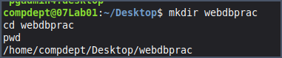
Step 4:
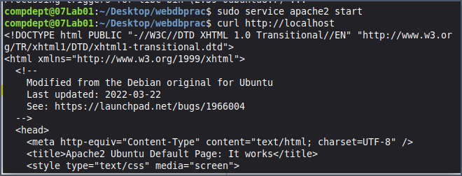
Step 5&6:
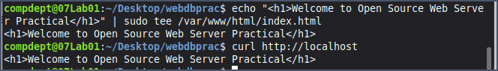
Step 7&8:
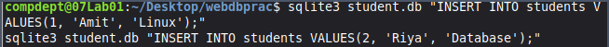
Step 9:
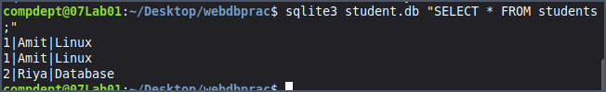
Step 10:
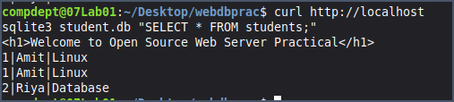
6. Error Handling / Troubleshooting
No blocking errors were encountered while performing this practical. A few common issues that can occur while setting up a web server and database, along with their cause and fix, are noted below for reference:
Issue: "E: Unable to locate package apache2" or "sqlite3"
- Cause: The local package list is outdated, or there is no active internet connection to reach the repositories.
- Fix: Run sudo apt-get update to refresh the package index and verify internet connectivity before retrying the install.
Issue: "Permission denied" while writing to /var/www/html/index.html
- Cause: The Apache document root is owned by the root user, so a normal write redirect (>) is blocked for non-root users.
- Fix: Use sudo tee /var/www/html/index.html instead of a plain redirect, as done in Step 5.
Issue: "curl: (7) Failed to connect to localhost port 80: Connection refused"
- Cause: The Apache service is not running, either because it was never started or it failed to start.
- Fix: Run sudo service apache2 start (or sudo service apache2 status to check) before retrying curl.
Issue: SQLite command runs but no output appears
- Cause: The .mode and column headers are off by default, or the table/database name was typed inconsistently across commands.
- Fix: Double-check the database filename (student.db) and table name (students) match exactly across CREATE, INSERT, and SELECT statements.
7. Important Insights
- sudo apt-get install -y apache2 sqlite3 can install multiple unrelated packages in a single command, saving time compared to installing them one at a time.
- sudo service apache2 start/stop/restart directly controls the Apache background process; the service must be running for curl or a browser to receive a response.
- Apache serves files from /var/www/html by default, and since this directory is root-owned, sudo tee (rather than a plain shell redirect) is required to modify files inside it.
- SQLite needs no separate database server process - the entire database lives in one file (student.db), which makes it lightweight and easy to move or back up.
- curl provides a fast, scriptable way to test whether a web server is reachable and what content it is returning, without needing a graphical browser.
- Testing the web server and the database together (Step 10) demonstrates how independent open-source components can be installed and verified as part of a single working environment.
8. Conclusion
This practical demonstrated how to install and configure an open-source web server and database on a Debian-based Linux system. A working folder named webdbprac was created, after which the package index was refreshed with apt-get update and the Apache web server and SQLite database were installed together using apt-get install. The Apache service was started and verified using curl, a custom HTML page was created and served from the document root, and a SQLite database was created with a students table into which sample records were inserted and successfully retrieved. A final combined check confirmed that both the web server and the database were working correctly together. Together, these steps illustrate the complete workflow of installing, configuring, and testing open-source server software on a Linux system.
9. Viva Questions
Q1. What is Apache and what role does it play as a web server?
Apache (apache2) is a free, open-source HTTP server that listens for client requests and serves web content - static files or dynamically generated pages - in response. It runs as a background service, listens on port 80 by default, and serves files from its document root (/var/www/html), making it one of the most widely used web servers for hosting websites and applications.
Q2. What is SQLite, and how is it different from a client-server database like MySQL?
SQLite is a lightweight, serverless relational database engine that stores an entire database - schema, tables, and data - in a single file, accessed directly by the sqlite3 tool or an application. Unlike MySQL or PostgreSQL, it does not require a separate database server process to be running, which makes it simpler to set up but less suited to handling many simultaneous remote connections.
Q3. Why is sudo required to write to /var/www/html/index.html?
The /var/www/html directory and its default contents are owned by the root user for security reasons, so a normal user does not have write permission there by default. sudo tee is used instead of a plain redirect because a shell redirect (>) is evaluated by the current user's shell before the command runs, and would fail even with sudo in front of echo; piping through sudo tee performs the actual file write with elevated privileges.
Q4. What does curl do, and why is it used in this practical?
curl is a command-line tool for transferring data to or from a server using protocols such as HTTP. In this practical it is used to send a request to http://localhost and print Apache's response directly in the terminal, offering a quick, scriptable way to confirm the web server is running and serving the expected content without opening a browser.
Q5. What is the difference between sudo service apache2 start and sudo service apache2 restart?
start launches the Apache service only if it is not already running, and does nothing (or reports it is already active) if it is; restart stops the currently running service and starts it again from scratch, which is typically used after changing Apache's configuration so the new settings take effect.
10. References: -
- Practical reference document (course material): https://docs.google.com/document/d/1NBZIxKOG4weVhsjOGzZYS-olCmyzyENaNSgQydzsBF0/edit?tab=t.0
- Apache HTTP Server official documentation: https://httpd.apache.org/docs/
- SQLite official documentation: https://www.sqlite.org/docs.html

